Class I Maths – 14th August 2019; Wednesday:
1. Count how many diagonal / slanting lines in this figure?
i. _________

ii._______

2. Two legs how many toes in all?
**********************************************

Class II Maths – 14th August 2019; Wednesday:
1. How much money in all?
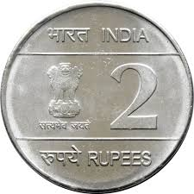 = Rs. _______

2. Match the following
A B
- i. A family of five

b.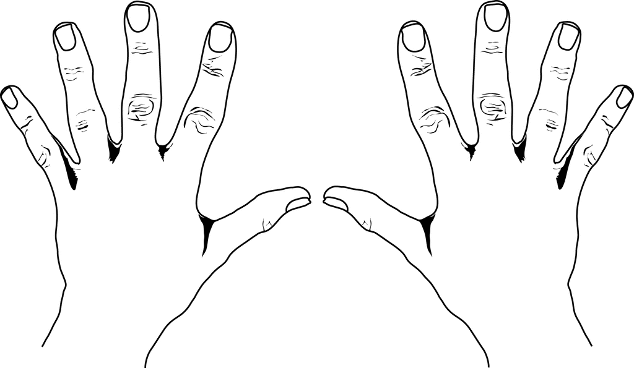 ii. One moon and many stars

c. iii. A pair of birds

d. iv. Ten fingers in two hands
**********************************************
Class III Maths – 14th August 2019; Wednesday:
1. Answer the following:
i. January 2019, February 2019 and March 2019 how many days in all? ___
ii. How many minutes in an hour? ____________

2. i. If a toy costs Rs 25 and a teddy bear costs Rs 57?
Which is costlier and by how much? __________
ii. Arrange in a descending order
739, 379, 973, 937, 793, 397
___________________________________________
**********************************************
Class IV Maths – 14th August 2019; Wednesday:
1. How many ¹/₅^{ths} (one-fifths)will make 2 wholes?
a. 2 [ ] b. 1 [ ] c. 10 [ ] d. 5 [ ]
2. What is the time at midnight 12 0’clock?
a. 12:00 hours [ ] b. 14:00 hours [ ]
c. 24:00 hours [ ] d. 00.00 hours [ ]
*********************************************
Class V Maths – 14th August 2019; Wednesday:
1. Which among the following CAN be measured in metres?
a. cloth [ ] b. rope[ ]
c. water[ ] d. height [ ]
2. A number is added to 526 and the sum obtained is a 3 digit number i.e. 5__6
What could be the number that is added?
i.e. 526 + ______ = 5_ 6
a. 100 [ ] b. 90[ ] c. 50 [ ] d. 4 [ ]
**********************************************
Class VI Maths – 14th August 2019; Wednesday:
1. Complete the series:
a. 1015, 9815, 9615, __________, _________
b. 17, 51, 18, 54, 19 ______, 20, ________

2. Which among the following cannot be measured in litres?
a. milk [ ] b. honey[ ] c. oil[ ] d. silver [ ]
**********************************************
Class VII Maths – 14th August 2019; Wednesday:
1. What is the ratio of boys and girls in a class of 120 pupils with 40 girls?
a.1: 2[ ] b. 3: 1 [ ] c.2:1 [ ] d.1:1 [ ]
2. Jatin has stamps of different countries. ¹/₃ of them are Indian stamps. If he has 390 Indian stamps, how many stamps does he have in all?
a.120 [ ] b. 1045 [ ] c. 780 [ ] d. 1170 [ ]
**********************************************
Class VIII Maths – 14th August 2019; Wednesday:
1. Which of the following is / are NEGATIVE rational number(s)? i. ³/₍₋₅₎ ii.⁽⁻³⁾/₍₋₅₎ iii.⁽⁻³⁾ /₀
a. only (i.) [ ] b. only (ii.) [ ]
c. only (i.) and (ii) [ ] d. all (i.). (ii) & (iii) [ ]

2. In a contest, a youth club collected 600 kg of rice. They packed it into EQUAL no. of 5 kg bags. How many bags of rice did they pack in total?
a. 40 [ ] b. 60 [ ] c. 80 [ ] d. 120 [ ]
Class IX Maths – 14th August 2019; Wednesday:
1. The ratio of boys and girls who have taken admission in 2018 in a nursing college is 1: 3. What will be their number of boys: girls if a total of 996 students have taken admission?
a. 747:249 [ ] b. 700 : 296 [ ]
c. 296 : 700 [ ] d. 249 :747 [ ]
2. There are 52 cards in a set of playing cards. Which among the following best describes the number of sets of Hearts, Spades, Diamonds and Clubs?
a. 13 + 13 x 4 [ ] b. 13 x 4 [ ]
c. 13⁴[ ] d. 4¹³ [ ]
****************************************************
Class X Maths – 14th August 2019; Wednesday:
1. The sum of three consecutive multiples of 3 is 72. What is the second largest number? a. 27 [ ] b 21 [ ] c. 24 [ ] d. 42 [ ]
2. In a class of 60 students, the number of boys and girls participating in the annual sports is in the ratio 3: 2 respectively. The number of girls not participating in the sports is 5 more than the number of boys not participating in the sports. If the number of boys participating in the sports is 15, then how many girls are there in the class? a. 20 [ ] b. 25 [ ] c. 30 [ ] d. 45 [ ]

*********************************************************
Class XI Maths – 14th August 2019; Wednesday:
1. Which among the following is not a perfect square?
i. 15625 [ ] ii. 4884 [ ]
iii. 325 [ ] iv. 360000 [ ]
2. Supply the missing numeral in the series
144, 169, _______, ________256, 289, _________, 361.
*********************************************
Class XII Maths – 14th August 2019; Wednesday:
1. Complete the following algebraic expressions
i. (x + y )² = _____________________________
ii. (x + y )(x -y ) = ________________________

2. Which among the following is known as Hardy-Ramanujan number?
i. 1729 [ ] ii. 9271 [ ]
iii. 1279 [ ] iv. 7291 [ ]
********************************************

